Penicuik High School
  - S6 Careers Resource 2018/19

Welcome to S6
Welcome back to sixth year. Since this is your last year at school, it’s essential to begin now to think about what you are going to do in the future. This book contains career planning resources that everyone can use this year.
As the school’s Careers Adviser, I am here to give you information and advice about the options open to you, so please get in touch if you need my help.

Help from Skills Development Scotland
If you would like help in deciding what to do when you leave school, you should register on Skills Development Scotland’s website My World of Work at www.myworldofwork.co.uk. As a starting point, use the online tools and quizzes on the website under Exploring Options to help identify areas of study or employment which might suit you. The website can also give you lots of useful information on applications, CVs, interviews, jobs and college. You can also call Skills Development Scotland’s Contact Centre for advice on 0800 917 8000.
If you have used the My Strengths tool and accessed My World of Work website and other resources to research information, but are still undecided about what to do, please speak to your Guidance teacher, who can refer you to me for a face to face interview in school.
I can also be contacted by phone at the Skills Development Scotland Centre in Musselburgh on 0131 665 3120 or by email at caroline.steele@sds.co.uk or speak to your Guidance Teacher for an appointment.

Caroline Steele
Careers Adviser
June 2018
caroline.steele@sds.co.uk
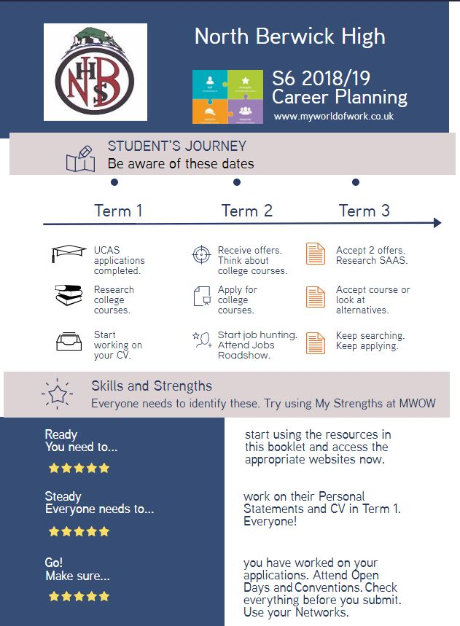

Higher Education Open Days 2018

IMPORTANT: - Check dates and times before going to Open Days.
Book on-line to reserve a place.

Institution | Date of Visit | Website address
Aberdeen University | Saturday 16 June 2018 – Medicine Open Day  Tuesday 28 August 2018 – General Open Day  Saturday 20 October 2018 – General Open Day | https://www.abdn.ac.uk/study/open-days.php
University of Abertay, Dundee | Saturday 6 October 2018  Wednesday 24 October 2018 | https://www.abertay.ac.uk/visit/open-days
University of Dundee | Medicine – Thursday 14 June 2018  Dentistry – Friday 15 June 2018  Main campus Open Days –Monday 27 August 2018 and Saturday 22 September 2018 | https://www.dundee.ac.uk/study/visitus/opendays/
University of Edinburgh | Friday 8 June 2018  Saturday 22 September 2018  Saturday 6 October 2018 | http://www.ed.ac.uk/studying/undergraduate/open-day
Edinburgh Napier University | Friday 8 June 2018 – open day for courses at Sighthill campus.  Friday 15 June 2018 – open day for courses at Craiglockhart campus.  Friday 22 June 2018 – open day for courses at Merchiston campus.  Saturday 13 October 2018 - open day at Merchiston, Craiglockhart and Sighthill campuses. | https://www.napier.ac.uk/study-with-us/undergraduate/meet-us/open-days
University of Glasgow | Glasgow campus – Thursday 14 June, Tuesday 28 August and Saturday 20 October 2018.  Crichton campus, Dumfries –Information Sessions – Wednesday 6 June and Wednesday 15 August 2018. Open Day Wednesday 3 October 2018 | http://www.gla.ac.uk/about/visit/undergraduateevents/  http://www.gla.ac.uk/schools/interdisciplinary/studyindumfries/visitus/visitdays/
Glasgow Caledonian University | Friday 31 August 2018  Saturday 6 October 2018 | http://www.gcu.ac.uk/study/opendaysandtours/datesandtimes/
Glasgow School of Art | Late October 2018. Check website for update on Open Day date. | http://www.gsa.ac.uk/life/gsa-events/events/o/open-day-2017/?source=filter&type=4875/recruitment-events
Heriot-Watt University | Edinburgh campus –Saturday 29 September and Friday 26 October 2018  Scottish Borders Campus, Galashiels – Friday 12 October and Friday 16 November 2018. | https://www.hw.ac.uk/uk/meet-us/edinburgh-campus-open-day.htm https://www.hw.ac.uk/uk/meet-us/sbc-open-day.htm
University of the Highlands and Islands | Various visit days at individual campuses. See website for information. | https://www.uhi.ac.uk/en/studying-at-uhi/open-days/
Queen Margaret  University, Edinburgh | Saturday 22 September 2018  Saturday 6 October 2018 | http://www.qmu.ac.uk/marketing/bulletins/opendays.htm
Robert Gordon  University, Aberdeen | Saturday 6 October 2018  Saturday 3 November 2018 | http://www.rgu.ac.uk/news-and-events/visit-us/undergraduate-events/open-days
Royal Conservatoire of Scotland, Glasgow | Music – Friday 15 June 2018.  Drama, Production & Film – Friday 17 August 2018  Production & Film – Friday 5 October 2018  Drama – Friday 19 October 2018  Ballet – Friday 2 November 2018 | https://www.rcs.ac.uk/studyhere/opendays/
SRUC - Scotland’s Rural Colleges | Various open days at individual campuses. Check website for full details. | https://www.sruc.ac.uk/info/120091/open_days_and_events
University of St Andrews | Wednesday 26 September, Wednesday 3 October, Wednesday 17 October, Wednesday 24 October, Wednesday 31 October 2018 | https://www.st-andrews.ac.uk/visiting/visiting-days/ug/
University of Stirling | Saturday 9 June, Saturday 15 September, Saturday 27 October 2018 | http://www.stir.ac.uk/visit-the-campus/open-days/
Strathclyde University | Tuesday 4 September 2018  Saturday 6 October 2018 | http://www.strath.ac.uk/studywithus/openday/
University of the West of Scotland | Ayr campus – Thursday 4 October 2018  Dumfries campus – Thursday 13 September 2018  Lanarkshire campus – Saturday 27 October 2018  Paisley campus – Saturday 29 September 2018 | http://www.uws.ac.uk/opendays/

If you are uncertain about any closing dates, check directly with the individual university or institution.

Useful Websites for Higher Education Applicants
www.ucas.com – UCAS (Universities and Colleges Admissions Service)
Details of degree courses throughout the UK. Includes course search by subject and/or institution, course profiles, university/college information, student finance. Also includes Apply, the on-line application system used by applicants to UK universities.
www.myworldofwork.co.uk – Skills Development Scotland’s website
Provides information on Higher National and Degree courses as well advice on how to choose a course and make your application.
www.planitplus.net - PlanIT
Contains information on all full and part time courses at Scottish colleges including Higher National Certificates/Diplomas, along with information on degree courses at Scottish universities.
http://unistats.direct.gov.uk – Unistats
Detailed information on the going rate for entry to courses. Also includes a survey of current students’ views of their course, including how it is taught and assessed, level of academic support provided, availability of learning resources including libraries and IT facilities. Data on graduate employment destinations for individual courses.
www.push.co.uk – PUSH Online
The ultimate Guide to student life, university and everything! Researched by students and recent graduates. Includes brief university profiles, university links to student unions/newspaper websites, information on how to apply, prices of beer, a jargon buster and lots more.
www.elrah.ac.uk – Edinburgh, Lothians, Fife and Borders Articulation Hub
Designed to help HNC/HND college students with progression on to degree courses at university. This site provides useful information for school leavers on links from HNC/D courses at local colleges to related courses at universities in south east Scotland.
www.prospects.ac.uk – Prospects
The essential guide to graduate careers, jobs and postgraduate study in the UK. Gives information about employment opportunities in its ‘What do Graduates Do’ section.
www.saas.gov.uk – Student Awards Agency for Scotland
Information on all aspects of student funding including bursaries and student loans. Scottish students studying in Scotland do not pay tuition fees for their courses. Some students may be eligible for a non-repayable bursary depending on the level of their family’s income. All students can apply for a non income assessed repayable loan. Look at this site to find out more about the cost of Higher Education.

Which University here
Best Course for Me here
Go Think Big here
Studential here
The Student Room here
Icould here

Important information for pupils
applying to Medicine, Dentistry,
Veterinary Medicine or Law courses

All applicants to degree courses in Medicine and Dentistry must sit an aptitude test. The UKCAT (UK Clinical Aptitude Test) is being used by all Scottish universities (and the majority of those outside Scotland). This is an aptitude test, which does not draw on any particular body of knowledge that a candidate can learn in advance. However there are practice questions on the UKCAT website.

You must register on-line to take the test. Registration should be made between 1 May 2018 and 18 September 2018. The test must be taken between 2 July 2018 and 2 October 2018. There is a test centre in Edinburgh. The cost of taking the test is £65 (2 July - 31 Aug) and £87 (1 Sept – 2 Oct). Bursaries may be available to cover the cost of the test depending on parental income. Closing date for bursary application is 18 September 2018.
More information is available on the UKCAT website www.ukcat.ac.uk.

The BMAT (BioMedical Admissions Test) is used by a small number of universities including Oxford, Cambridge, Brighton and Sussex Medical School, Lancaster University, University of Leeds, Imperial College, London and University College, London for entry to Medicine, by University of Leeds for Dentistry and by Oxford for Biomedical Sciences. Next test date is on 31 October 2018. Registration is between 1 September and 1 October 2018. Test fee is £46.00. More information at www.bmat.org.uk.

The LNAT (National Admissions Test for law) is being used by Glasgow University (and other institutions outside Scotland) to assess applications to all courses in Law, including joint degrees in Law and another subject. Full details of test dates and registration are on the LNAT website www.lnat.ac.uk.

Start to think about how to write your Personal Statement for UCAS applications and what to include.

- Remember to allow yourself plenty of time to work on creating a good personal statement. Universities decide on their offers based mainly on your statement and your exam results.

- Timeline for this here

- Online personal statement tool here

- More help on this is here

- Link to UCAS advice for parents and carers here

- More on applying to university and/or college here

Planning Ahead
Don’t have a clue: | - Think about your skills, strengths and interests as discussed at today’s session  - Visit www.planitplus.net/careerzone/careerometer You can use the computers in the school library or at home to do this and it will help generate some ideas.  - Register on www.myworldofwork.co.uk for careers information and resources.
Have some ideas but need to explore options available: | - Visit www.planitplus.net for career and course information  - Try getting some relevant work experience or work shadowing.  - Start to research the post-school options outlined below using the available resources.

Post-school options and resources
Further Education | - Visit www.planitplus.net for course availability  - Read college prospectuses in the careers library and/or visit college websites:  Edinburgh College - www.edinburghcollege.ac.uk  Oatridge College – www.sruc.ac.uk  There are many other colleges throughout Scotland which you can explore in more detail through the Planit website
Higher Education | - Visit www.ukcoursefinder.com you can take a quiz to help you identify course ideas  - Visit www.ucas.com and www.planitplus.net for course information  - Visit www.saas.gov.uk for financial advice  - Visit www.push.co.uk for student advice  - Visit www.prospects.ac.uk for degree course progression  - Read university prospectuses in the careers library or visit university websites.  - Attend the Higher Education Convention at Ingliston on 4th September 2018
Employment/ Training | - Register on www.myworldofwork.co.uk for help with CV’s and interview skills  - There are lots of job search websites; you can access some links to these on www.edubuzz.org/midandeastvacancies  - Visit www.yell.com or use the Yellow Pages or local trade directories to identify employers to contact about recruitment.  - Try to get some relevant work experience or work shadowing or do some volunteering – try www.volunteermidlothian.org.uk
Year Out | - Visit www.yearoutgroup.org www.summerjobs.com and www.gapyear.com  - Think about what you hope to gain from a year out.  - Plan what you would like to do at the end of your year out too  - Country guides here to help you

START PLANNING NOW!

College Resources

Edinburgh College
Scotland’s Rural Colleges
Pre-application resources here
Higher National level funding here
HN to degree progression routes here
Scottish Qualifications Framework here
Finding Employment

CV preparation here
MyWOW Cover letter information here
MyWOW Cover letter layout and examples here
MyWOW Cover letter information here
MyWOW Cover letter layout and examples here
MyWOW – Interviews help here
MyWOW – My Interview here
Some Vacancies Information here

