Higher Media Analysis paper
Section 1 - Essay questions – Get Out
- Questions 1 and 2 each ask you to write a 2-part essay making connections between the key aspects (categories, language, narrative and representations) and the contexts (society, institutions and audience).
- Question 1 will specify a context in part a) and give you a choice of three key aspects to write about in b)
- Question 2 will specify one key aspect in part a) and give you a choice of the remaining two contexts to write about in part b)

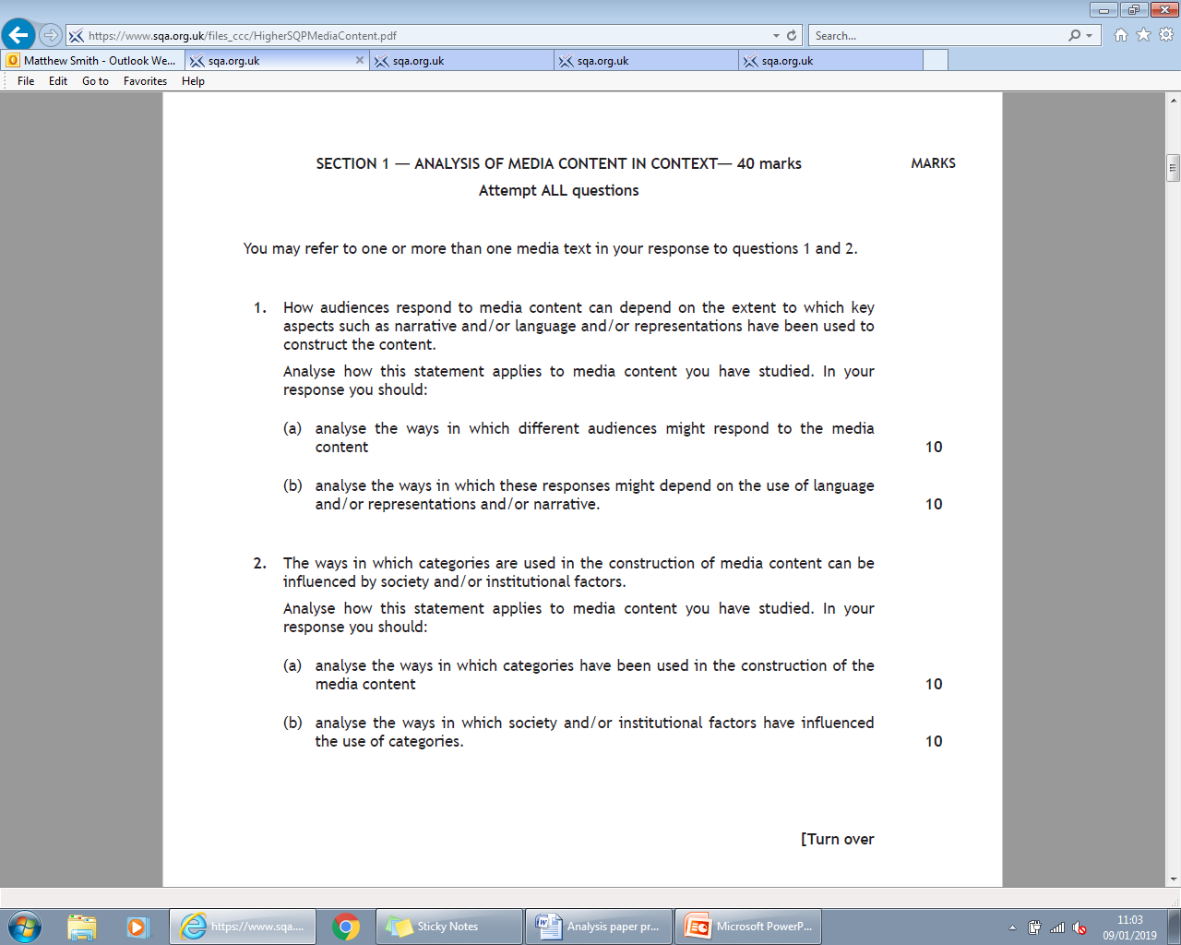
To show you what this looks like, here are the two questions from the SQA Specimen paper:
Essay Planning Advice:
No matter which key aspects or contexts you are asked to write about, you need to follow a similar structure for each essay:
Part a) – aim to discuss at least 2 (ideally 3) different concepts from the key aspect/context (i.e. different narrative theories; different sequences for language; different institutional or society factors etc.). For each one:
- Decode (describe) the concept in detail
- Give detailed evidence from the film showing how the concept can be seen in it
- Comment in detail on why the concept has been used the way it has
Part b) - aim to discuss at least 2 (ideally 3) different concepts from the key aspect/context (i.e. different narrative theories; different sequences for language; different institutional or society factors etc.). For each one:
- Decode (describe) the concept in detail
- Give detailed evidence from the film showing how the concept can be seen in it
- Comment in detail on how this use of the key aspect has influenced/been influenced by the key aspect or context you wrote about in a)

To see what this looks like in practice, on the next page there is a sample essay question with an example of how you might go about answering it. The plan is only an outline of the essay – you would need to fill in some of the details and the comments for yourself, and there are plenty of other ways you could successfully answer the question.

1. Media Content in Context
Internal and external institutional factors often influence the ways that key aspects of media content such as categories and/or representations and/or language are constructed.
Analyse how this statement applies to media content you have studied. In your response you should:
- give detailed information about internal and/or external institutional factors which have influenced the media content; 10
- analyse how categories and/or representations and/or language codes have also been influenced by these institutional factors. 10

SAMPLE ESSAY PLAN:
(The question asks you to focus on Institutions for part a) and gives a choice of key aspects for part b) – in this plan I have given a range of possible points for each of the key aspects in part b), but you would probably only have time to make 3 or 4 of them in the exam. The points given are only a selection – there are many more you could make for each of the key aspects …)
Begin with a sentence or 2 saying which film you are writing about, naming the director and giving the year of release, e.g.
‘Get Out’, written and directed by Jordan Peele and released in 2017, is an innovative horror film that powerfully exposes the racism that still lies beneath the surface of modern America.
Then:
A) – INSTITUTIONS
- Institutional factor 1 – budget and production company:
  - Peele’s original idea was taken on by Blumhouse productions
  - Blumhouse production model cuts costs, but also gives plenty of creative control to filmmakers. All talent is paid scale; post-production is done in-house; no original film has a budget of more than $5 million. ‘Get Out’s budget was only $4.5 million, though it made over $250 million worldwide.
  - Therefore costs had to be kept down, and this affected the film in several ways. As there was no money for elaborate special effects, the film’s iconic ‘sunken place’ scenes were filmed ‘dry for wet’ (i.e. in slow motion, with wind machines to give the effect of rippling clothing etc.) on a soundstage. Not only was this a cheap and effective way of filming the scenes, but it also proved very effective, as the emptiness around Chris as he ‘falls’ backwards into the void is a powerful visual metaphor for his helplessness and sense of panic.
  - Another way this factor affected the film was in the crucial party scene, where the Armitages show Chris off to their friends. As there was no budget for lots of extras, the scenes were choreographed so that Chris was always framed with the guests surrounding him. This was not only cost-effective but also created a very eerie tone in the sequence, and helped to create the sense that the guests are interested in Chris in a very sinister way.
  - Also affected the ending: Blumhouse wanted the film to make a profit, so when the original downbeat ending of the film played badly with test audiences, Blumhouse asked Peele to come up with a different ending, and he chose to show Chris reunited with Rod and escaping safely from the Armitages. This proved very effective because the film was able to end on a hopeful note, which Peele felt was more appropriate as movements like Black Lives Matter were providing more hope for resistance to racism in the real world, while the way the scene was shot allowed much of the force of the original ending as when the audience sees flashing lights they assume it’s the police, increasing the relief when it turns out to be Rod.

- Institutional factor 2 – Casting
  - Another institutional factor that depended on the film’s budget was the casting. As Blumhouse don’t pay up-front fees to actors, preferring to pay them standard union pay and offer them a percentage of the film’s takings if successful, they are unable to cast major A-list celebrity actors who would normally individually be paid much more than the entire budget for ‘Get Out’.
  - This means, however, that anyone who is involved in a Blumhouse production is there because they believe in the production, and that has major benefits. For instance, Daniel Kaluuya, who plays Chris, brought his own experience of racial profiling by British police to the role, making his performance much more authentic and convincing, especially in the scene where the policeman asks to see his license.
  - Alison Williams, who plays Rose, took the part because she wanted to make a radical break with her image as an innocent ‘WASP princess’. This made the climax of the film, when she is revealed to be completely evil, even more effective as white audiences find it hard to believe she was lying to Chris all along.
  - The film was also able to attract well-respected character actors such as Bradley Whitford, well-known from his roles in ‘The West Wing’ and ‘Transparent’, who was able to provide a highly convincing portrayal of Dean Armitage as a well-meaning white liberal in the early scenes of the film and also was able to shock audiences through his transformation into an evil white supremacist as the film goes on.

B) – KEY ASPECTS + INSTITUTIONS
- Categories
  - Horror convention 1 – The ‘bad place’ – unconventional because it is not a basement, haunted house, cabin in the woods etc. but instead a beautiful mansion with perfectly-kept grounds. [describe setting in more detail] This is effective, though, because it clearly shows the film’s message that ugly racism lies beneath the surface of American society. It was positively influenced by the institutional factor of budget, because originally filming was due to take place in California, but when the production failed to get a tax rebate, they moved to Alabama to save money. The property they found had elements of a stereotypical Southern mansion, with its classical columns and wooded grounds. It therefore was very effective at subtly hinting at the history of slavery in the Southern states.
  - Horror convention 2 – the ‘villain’. Usually horror villains are monsters, masked killers or supernatural forces. However in ‘Get Out’ they are respectable middle-class white people, who are gradually revealed to be white supremacists who steal the bodies of black people to help their white friends live longer through gruesome brain transplants. [Analyse how the Armitages are revealed to be monsters] This was positively influenced by institutional factors because the casting of Alison Williams as Rose made it almost impossible for audiences to believe she could be villainous and so it was especially shocking when they discovered that she was completely heartless (e.g. the scene when she is choosing new victims). This was especially effective in allowing the film to achieve its purpose of showing how all-pervasive racism is.
  - Purpose – the film aims to show not only how serious America’s problem with racism still is, but also to give a sense of hope that black people can resist it and fight back against it. Institutional factors affected this positively because Blumhouse’s insistence on changing the ending to please test audiences meant that the film was able to end on a positive, uplifting note as Chris is reunited with Rod and escapes, rather than being arrested and imprisoned for murder (as happened in the original ending). [explain how this helps to achieve the film’s social purpose, linking to BLM etc.] By pleasing the audience in this way, the ending also helps to fulfill the institutional desire for profit.

- Language
  - [Analysis of language in pre-credit sequence] – links to budget because the whole sequence is filmed cheaply using a hand-held camera and only two actors. Effective because the hand-held camera allows the audience to identify with Andre’s point of view and share his fears, establishing the film’s themes of racism and the vulnerability felt by black people in a white environment. Also links to copyright law/music licensing: the use of ‘Run Rabbit Run’ establishes a creepy tone, and the fact that Blumhouse paid to license an old scratchy recording helps suggest the idea that violent racism is emerging from the past to threaten modern black people.
  - [analysis of language in party sequence] – links to budget because the fact they couldn’t afford extras forced them to use the same smallish group of people, clustered around Chris to create the impression they are unhealthily fixated on him, thereby making the sequence more effectively sinister.
  - [analysis of ‘twist’ scene where Rose is revealed to be evil] – links to casting because the climactic moment where Rose holds up the keys and says ‘you know I can’t do that, babe’ depends heavily on the audience having previously believed in Rose and thought she was genuinely on Chris’ side. Alison Williams is so convincingly likeable as Rose throughout the film that when we see the close-up of her looking agonized and then suddenly changing her expression as she holds up the keys she had supposedly been looking for, it comes as a massive shock to the audience.

- Representations
  - The representation of America as colourblind and post-racial is created through the post-credits sequence where we are introduced to Chris and Rose’s relationship. As the camera moves through Chris’ apartment it reveals a comfortable, stylish living area furnished with arty black-and-white photos (Chris’ own work). The comfort of the apartment creates a representation of a successful young man, making a living through creative work in a large American city, and therefore suggesting that there are no racial barriers to success. This film appears to confirm this ideology in the portrayal of the relationship between Chris and Rose: their relaxed, comfortable body language, and the light-hearted easy-going dialogue between them [Give examples] establishes them as a happy mixed-race couple, appearing to confirm the dominant ideology that suggests there is no racial barrier to romance. This links to casting because both Daniel Kaluuya and Alison Williams are charming and likeable actors, and Alison Williams in particular is able to use the innocent, ‘good-girl’ image she has established through previous roles to encourage the audience to like her [You could add some comments on how costume is used to anchor these representations].

  - The representation of Rod as the comic side-kick is created through a number of scenes (analyse some of his conversations with Chris; his encounter with the police, to show how the stereotypical comic side-kick representation is created). This links to casting as Rod is played by Lil Rel Howery, an experienced comedian who was able to use his improv comedy skills to improvise much of Rod’s dialogue. The fact that Peele was happy to allow the actor to do this also connects to the institutional factor of the Blumhouse production model. The cast have spoken about how the fact that they stayed together at the same hotel (a budget-saving measure) helped create a sense of trust and a ‘family’ atmosphere which encouraged improvisation, and the Blumhouse approach of allowing creative freedom to filmmakers meant that Peele could trust his own judgments without worrying about excessive studio interference.

PRACTICE PAPER

Analysis of Media Content in Context

1. It could be argued that ideas within a society are reflected in the use of key aspects such as categories and/or narrative and/or language codes.

Analyse how this statement applies to media content you have studied. In your response you must:

(a) give detailed information about ideas in society which are reflected in the
media content; 10
(b) analyse how categories and/or narrative and/or language codes reflect these
ideas. 10

2. The way that media content represents people and/or places and/or ideas can be affected by institutional factors and/or intended audience responses.

Analyse how this statement applies to media content you have studied. In your response you must:

a) analyse how representations have been constructed in the media content; 10
b) analyse the ways in which representations have influenced or been influenced by audience factors and/or institutional factors. 10

