EXCLUSIVE: Alfonso Cuaron On 'Children of Men'
0
COMMENT

A chance to sit down one-on-one with the director of one of the best films of the year
By: Brad Brevet
Published: Friday, December 22nd 2006 at 8:43 PM
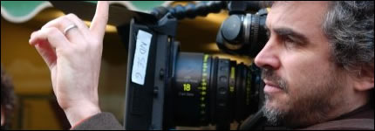
I told you there would be more Children of Men and after our interview with star Clive Owen you may wonder how I could top that. Well, how about an exclusive one-on-one interview with director Alfonso Cuarón? With Children of Men Cuarón has delivered one of the year's best films, not only because of the story, but wait until you see how ambitious he was behind the lense. This film is comprised of so many one shots (scenes in which there are no edits) it will blow you away, especially one scene in a moving car that needed so many things to go right you might think it would be impossible, but it wasn't. At least not for Alfonso.
Before Children of Men Cuarón directed Harry Potter and the Prisoner of Azkaban, a film author J.K. Rowling herself has referred to as her favorite. However, with Children of Men Cuarón raised the bar and even if Oscar doesn't give him the credit he deserves RopeofSilicon already has with my "A-" review right here.
So sit back and take some time to learn about the making of Children of Men and learn more about this visionary director as he talks about the film, his ambition and a bit about his friends Guillermo del Toro (Pan's Labyrinth) and Alejandro Gonzalez Iñárritu (Babel).
Was there ever a moment when you looked at how ambitious you were being with this film and said I have to stop this?
AC: Every single second.
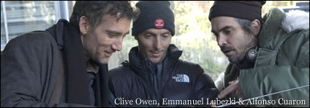
Clive said that you decided on the day of the birth scene you were going to do this in one. He didn't even know and you spring it on them that day? Where does this come from?
AC: Emmanuel Lubezki, the cinematographer, who won at Venice [Film Festival] this year for Best Cinematography and I discussed from the beginning that even though the canvas and the scope was way bigger than Y Tu Mama Tambien that this production was going to be the same in the sense that character is as important as social environment. That means that there are no close-ups, everything is seen from a distance and also we are trying to avoid editing seeking for an effect. Rather than that we tried to create moments of truthfulness and to have the camera registering that moment of truthfulness. So that was the core of everything, let's try to create the moment of truthfulness and the camera has to be just serving that moment.
You changed the timeline from the book, instead of 30 years you went with 21. Was this so you didn't have to think about supersonic cars, special effects and crazy architecture? You didn't try to create Minority Report, which I think would have taken away from the film.
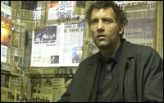
AC: That is the thing, to contrive the story of infertility we needed to set it in the future. Now we wanted to set it in such a near future that everything would be recognizable as today. We tried to avoid completely the high-tech scenario. When I started working on the film I met with the art department and they undusted all the old rejections from science fiction movies they had done, they were so excited to do this movie that took place in the future. They started showing me all these amazing things. Supersonic cars, buildings, gadgets and stuff and I was like, "You guys this is brilliant, but this is not the movie we're doing. The movie we are doing is this," and I brought in my files. It was about Iraq, Somalia, Sri Lanka, Northern Ireland, the Balkans, Chernobyl and I said this is the movie we are doing. The rule I set is this movie is not about imagination, it is about reference.
One thing I noticed when seeing it was when you go into those refugee camps at Bexhill it looks a lot like Road to Guantanamo, which was brutal. Was that your goal?
AC: The whole premise was to try to create a journey through the state of things. So people raise the question about the possibility of hope in the reality of this world.
Is this a "message movie" and if so what kind of message are you trying to get across?
AC: I tried to make an observation rather than to give a statement. Ideally I want audiences to come out with their own conclusions. I stopped believing in movies that end when the lights come on, in which you give your statement and the lights come on. Now I believe in the movies that start when the lights come on, in which you present a statement of things and allow audiences to make their own conclusions.
It seems a lot of movies this year are very depressing, but while Children of Men is a bleak look at the future there is a moment of hope at the end. Was that your intention?
AC: The film is about hope, but I don't think you can impose a sense of hope. It's like democracy, you cannot impose democracy. [laughing] The sense of hope is something you cannot impose, it is something that is so personal. You can impose it in a Hollywood, hypocritical, manipulative movie in which you create your hopeful ending and everybody feels like so pretty.
Well people were coming out of this movie still talking about how bleak and dark it is.
AC: It pretty much depends on your own sense of hope. What we wanted to do at the end was to give a little glimpse of a possibility of hope. A very small glimpse. So you invest your own sense of hope in the story. After you go through this journey of what I consider to be the state of things, outside our green zones, then at the end is the question: Do we have a possibility of hope? I personally believe yes. Hopefully people believe that the movie is a very hopeful movie.
Is there any of you inside Theo? His character begins with no hope and goes through this transition and you have said you are a very hopeful person. I am just wonder if any of that bled into the character.
AC: I am sure there is, funny thing is, now that you say that, my brother was presenting one of my films in New York's Lincoln Center a couple of months ago and he was saying that I tend to mimic my films, "When he was doing Little Princess he became a little princess. When he was doing Great Expectations he became this social climber. When he was doing Y Tu Mama Tambien he became a teen, in Harry Potter he became this fantasy guy and with Children of Men he's been this guy in despair about society and the world around him." The core of that is that you get attracted to stories because in a way they are a part of you and in a way that you want to come to terms with.
It seems you become incredibly immersed in your films with all the realism and even with Harry Potter it is the most moody and emotional film of the first four. Is that you goal to bring a certain sense of reality and mood to your films?
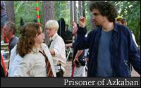
AC: You can do whatever you think is right from your own standpoint. The truth is there is mostly an instinctual thing with what you think is right. Once I make a choice then I go into a huge amount of research. Like in this film the research wasn't so much about gadgetry and how the world would be in years to come. In this film the research was about bringing the perception that great minds have about the state of things today. I immerse myself into the different perceptions of what all these great minds have about what we perceive as reality today.
Taking your ambition with this film into consideration is there ever a moment where you are worried about taking certain films on, such as films like Harry Potter and filmmaking techniques such as all the one shots in Children of Men?
AC: No, I cannot make a decision about what movie I am going to do from the standpoint of what is going to be good or bad for my career. I cannot act based on fear because then I make the wrong choices. I have to do make decisions on what my stomach, my heart is dictating. Now, once I make the decision, I become terrified. [laughing]
That's what I am thinking with Children of Men and you making that decision to do it all in one…
AC: That is the fearless decision, I am going to make everything in one. Once you make the decision there is no way back and from then on you live terrified.
I would think so.
AC: It's like, "Fuuuuck, I have twelve days to do this scene and on day ten I haven't rolled camera," at that point it's like, "Shit, what if it doesn't work out?" Then you realize if it doesn't work out it's a major collapse of the production. I have to say these guys were so patient with me in the sense of knowing the risk that everything entailed and at the same time being nothing but supportive.
One other thing, I think you and Guillermo talked about it at Comic Con, you Guillermo and Alejandro are going to be collaborating on a project of some sort. Is that true?
AC: We've been talking about forever about doing a film in which we have one event which you would see from three different points of view and each of us doing one perspective.
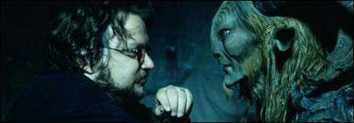
That would be a wild movie because you three are so widely varied in styles. Especially Guillermo!
AC: Last night, it was my premiere, and I was there with Alejandro and I don't know how late into the night we were talking about Guillermo's film. More than the visuals, it is the conceptual, spiritual resonance of the film. It is really magical. He did something very special.
I also like how he sticks to his guns, such as in the way he has fought to get Hellboy 2 made.
AC: You have to hear him, he says, "This is my most personal screenplay," he says about Hellboy 2. So I believe him.

