How advertising hijacked feminism. Big time

Adland has fallen in love with feminism. Hard. 'Femvertising' is now big business - but is that something to 'celebrate'? Claire Cohen reports

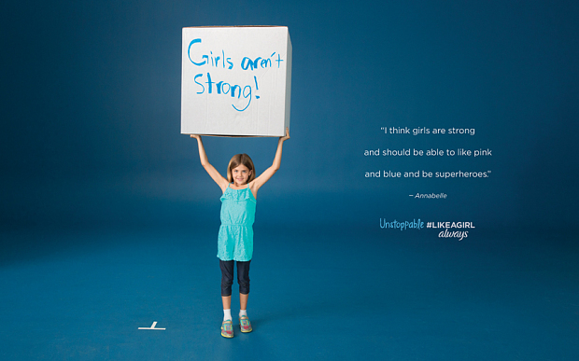
Photo: Like a Girl Always

By Claire Cohen
11:09AM BST 09 Jul 2015

It all started with Dove. A decade ago, in 2004, the soap brand launched its 'real women' campaign. For many, myself included, it was the first time we'd seen a group of recognisable women, of varying shapes, sizes and ethnicities, in advertising. Here was something different - not without its flaws - but much better than another ad showing mum serving up the Sunday roast or exclaiming how white her whites were.

Yet in the intervening years, nothing much else had come along to give Dove any serious competition.

Until now.

Because in the last 12 months, everything has changed.

Over the last year, we've seen women in ad campaigns dispel negative stereotypes (#LikeAGirl by Always); sweat it out in the gym (This Girl Can - Sport England); stop being self-critical (Dove again); talk about periods (Hello Flo) and quit saying 'sorry' (Pantene). Oh and, a personal favourite, seen Potty-Mouthed Princesses Drop F-Bombs for Feminism, dreamed up by fashion brand FCKH8.
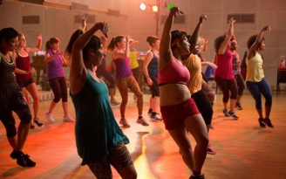Zumba: This Girl Can style...

Welcome to the world of femvertising: where the hard sell has been 'pinkwashed' and replaced by something resembling a social conscience, and where advertisers are falling over each other to climb on board the feminist bandwagon. And this week - we had the latest chapter of #LikeAGirl from Always.

On the face of it, this might seem like a giant step forward for the industry. But is it as heartwarming as it seems? Aren't we still just being sold to? Surely half the world's population can't be 'having a moment'. "There's been a groundswell towards brands telling the truth and getting behind a cause," Mediacom CEO Karen Blackett tells me. "Once upon a time ads were aspirational. But now they have to tell real stories, based on what we all experience".

Roisin Donnelly, brand director at Proctor and Gamble agrees. "Adverts now have to reflect our reality and the future we want. That means role models for women."
So rather than objectifying women and selling them idealised versions of themselves, the advertisers are cottoning on to the idea that honesty sells too.
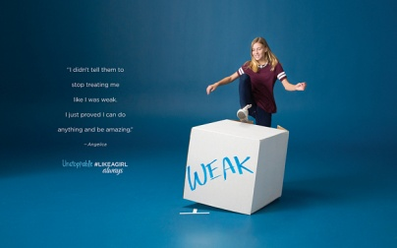A still from the new feminist Always campaign

It's what women want. Last year, lifestyle website SheKnows surveyed more than 600 women about femvertising. A staggering 91 per cent believed that how women are portrayed in ads has a direct impact on girls' self-esteem, and 94 per cent said that depicting women as sex symbols is harmful. It also showed that femvertising can pay - half (52 per cent) had purchased a product because they liked how the ads potrayed women. Blackett suggests the move towards honesty in advertising is, in part, down to the recession.

But I think the answer is much simpler: social media. Women have long held the spending power. Now, through social media, we've found a place to communicate that. We can hold advertisers - and anyone else perceived not to be meeting our needs - directly accountable (think Protein World's 'beach body ready' billboards). We can expose the realities of female life (#EverydaySexism) and rally behind causes via hashtag activism (think #bringbackourgirls #iammalala #yesallwomen). We can go into battle to see Jane Austen out on the tenner or to defend the victims of Gamergate.

Here is a place where the soft power - read influence - of women has never been more apparent. Our online presence is dominant (we use social media more, and we do 62 per cent of all online sharing). We also have increasing power in the workplace - British boards now have 23.5 per cent women according to the latest Lord Davies report.

Combine the influence of Facebook and Twitter with the potency of Sheryl Sandberg's Lean In message and you're starting to see how we got here. Little wonder that advertisers feel they have to get on board.

The latest burst of femvertising began with two near simultaneous campaigns last summer; Sport England's This Girl Can and #LikeAGirl from Always.
Jennie Price, head of Sport England, tells me: "For a long time we'd wanted to tackle the gender gap, but we felt it was important to start with the women and not the sport. There was no point sticking a skirt on something seen as a 'male activity' to make it seem feminine.
"Turns out, other people were thinking the same thing".

This Girl Can, which shows 'real women' (a phrase I don't much like - who isn't real?) putting themselves through their paces. They sweat, grunt, grimace and push themselves to the limit as they exercise. It's a powerful message and one that's also had plenty of ad-world back slapping (along with #LikeAGirl it won a coveted glass lion at the Cannes Lion ad awards earlier this month). The starting point for the campaign was research: through talking to women came the realisation that they weren't doing sport out of fear of being judged, even though 75 per cent wanted to.

Always' #LikeAGirl campaign was born from a similar place - studies done by the brand that showed a significant drop-off in girls' confidence during puberty. The original video, released last June, showed girls and women reacting in different ways to the phrase 'like a girl'. Its latest instalment, launched this week, tackles confidence and those things girls are told they can and can't do.

Here then are two ad campaigns that, on the surface, seem to eschew the hard sell in favour of social improvement (after all it's hard to measure whether a soft campaign is actually encouraging girls to buy more pads).

The advertisers asked women and girls how they felt and - instead of feeding them back what they think they wanted - chose to portray what they'd been told: our deepest insecurities (some have criticised such ads for knocking women down so they can build them up again).
Of course, we're still being sold to and that's the rub. Question is: do we care? As long as the right messages are reaching audiences, can we overlook how they get there?

While Pantene's 'sorry' advert was admirable, it's hard to see how having shiny, swingy hair is going to further equality. And Karl Lagerfeld sending Chanel models down the SS15 catwalk wearing couture and holding placards that read 'Feminist but Feminine' was horribly contrived.

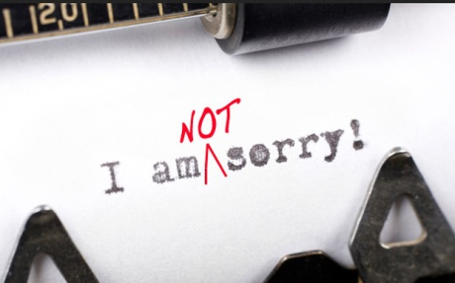Pantene's sorry advert prompted discussions

It smacked of a company adopting feminism because it seemed trendy; out of self interest. That’s where brands like Sport England and Always have got it right - they're turning the mirror back on us. The moment those women in the first #LikeAGirl ad understood they'd been fed a cliche about their own gender was powerful, regardless of the motive.

As director Lauren Greenfield (behind #LikeAGirl) told Telegraph Wonder Women in an exclusive blog at the time:
"When these moments of realisation occurred in real time, we knew something profound was happening in front of the cameras. Both I and some of the women on set were moved to tears".

That's the power of femvertising done right. It brings us together in an - often funny- moment of self-recognition, before pulling back the curtain to expose an ingrained cultural stereotype.
Roisin Donnelly tells me that #LikeAGirl has now been seen by 85 per cent of schoolgirls in the UK, largely through them sharing it with each other. And a version of the ad was shown during this year's Super Bowl in the US - the first sanitary towel brand to do so.

The word 'girl' being adopted and shared among girls is one thing. But how does it sit with women? I asked Jennie Price whether it could be seen as condescending. "Girl was a word we really tested," she tells me. "It was key to us not to be patronising. In the end, we decided that it was OK to call ourselves girls and reclaim the word."
"It was even the theme of my teenage daughters' sports day," adds Donnelly.

Indeed, femvertising is hugely popular with millennials who, recent studies show, value ethics over money.

Little wonder brands are going above mere broadcast campaigns to appeal to this audience. Always has is setting up an education programme to get information about puberty into schools. Pantene has started the Shine Strong fund to support the American Association of University of Women’s Campus Action Project. Verizon, who made 2014's Inspire Her Mind ad, aimed at getting more girls into STEM subjects is handing out financial awards to schoolgirls.

But this younger generation of women will see through such advertising strategies if they become too shallow. The more brands strive to appeal to them via 'social movements' or experiments, the more they risk becoming formulaic.

To remain convincing, such campaigns can't just push the perceived feminist agenda through a hard sell. They need ads that are built for women by women, from the ground up.
Part of the problem, of course, is that currently only three per cent of creative directors are female. "Although we are seeing more thank the lord," says Karen Blackett who says in the past much of the industry was "male, pale and stale".

So where next for femvertising? Personally, I think we desperately need more diversity on our screens. Dove and Pantene might be tackling issues of female low self-esteem, but they're still selling cosmetic products and most of the women in their ads wouldn't look out of place on the catwalk.

We also need to see more men taking on traditional 'woman's jobs' around the house (Donnelly tells me that in Iceland and Nordic countries it's the norm to see men washing up on screen. But those nations are also light years ahead in terms of gender equality - a self fulfilling prophecy perhaps.)

Plus, if femvertising is truly going to be real isn't it about time we saw red, not blue, liquid used in ads for sanitary towels and tampons? (It's a myth that ASA rules prohibit this).
Karen Blackett tells me we need to reach a place where the 'women's angle' ceases to be noticeable. "We need to see a move away from 'feminist ads' to a place where all adverts have an inherently female viewpoint," she says. "We need to normalise the experience of being a woman in advertising. If companies have any sense at all they will embrace it and future proof their business."

Price agrees: "We need to normalise this tone of voice and not make women out to be special. We need to reach a point where we're not different".

From

http://www.telegraph.co.uk/women/womens-life/11727478/How-advertising-hijacked-feminism.-Big-time.html

