H
City of Edinburgh Council

Prelim Paper – 2018-19

Higher Media Prelim Paper 1:
Analysis of media content

Date — 2018-19
Duration — 2 hours 15 minutes

SECTION 1 — ANALYSIS OF MEDIA CONTENT IN CONTEXT— 40 marks Attempt ALL questions.
SECTION 2 — ANALYSIS OF MEDIA TEXTS — 10 marks Select ONE PAIR from the following media texts: Pair A — Film posters (pages 04–05) or
Pair B — Magazine covers (pages 06–07) or
Pair C — Advertisements (pages 08–09) and attempt the question on page 03.
Write your answers clearly in the answer booklet provided. In the answer booklet you must clearly identify the question number you are attempting.
Use blue or black ink.
Before leaving the examination room you must give your answer booklet to the Invigilator; if you do not, you may lose all the marks for this paper.

SECTION 1 — ANALYSIS OF MEDIA CONTENT IN CONTEXT— 40 marks

MARKS
Attempt ALL questions
You may refer to one or more than one media text in your response to questions 1 and 2.
- The society in which media content is made often has an impact on key aspects such as
language and/or categories and/or representations which are used in its construction.

Analyse how this statement applies to media content you have studied. In your response you should:

a) give detailed information about society factors and how they have had an impact on the media
content 10
b) analyse the ways in which these society factors have had an impact on the use of language and/or representations and/or categories in the media content. 10

- The ways in which narrative is used in the construction of media content can be influenced by audience
and/or institutional factors.

Analyse how this statement applies to media content you have studied. In your response you should:

a) analyse the ways in which narrative structures, codes and/or conventions have been used in the construction of the media content 10
b) analyse how the narrative elements have been influenced by audience and/or institutional factors relevant to the media content. 10

[Turn over]

page 02

SECTION 2 — ANALYSIS OF MEDIA TEXTS — 10 marks

Select ONE PAIR from the following media texts:
PAIR A — Film posters (pages 04–05)
or
PAIR B — Magazine covers (pages 06–07) or
PAIR C — Advertisements (pages 08–09) and attempt the question below.
Write the letter of your chosen pair of texts (A, B or C) in the margin.
- Analyse in detail how relevant key aspects of media literacy have been used in similar and/or different ways in your chosen pair of media texts. You must make reference to both texts.

In your answer you must make at least five developed points of analysis, and refer to at least two of the following key aspects:
- Language
- Representation
- Categories
- Narrative
- Audience
- Institutions
- Society

10

page 03
SECTION 2 — Pair A
Film posters

page 04

SECTION 2 — Pair A
Film posters
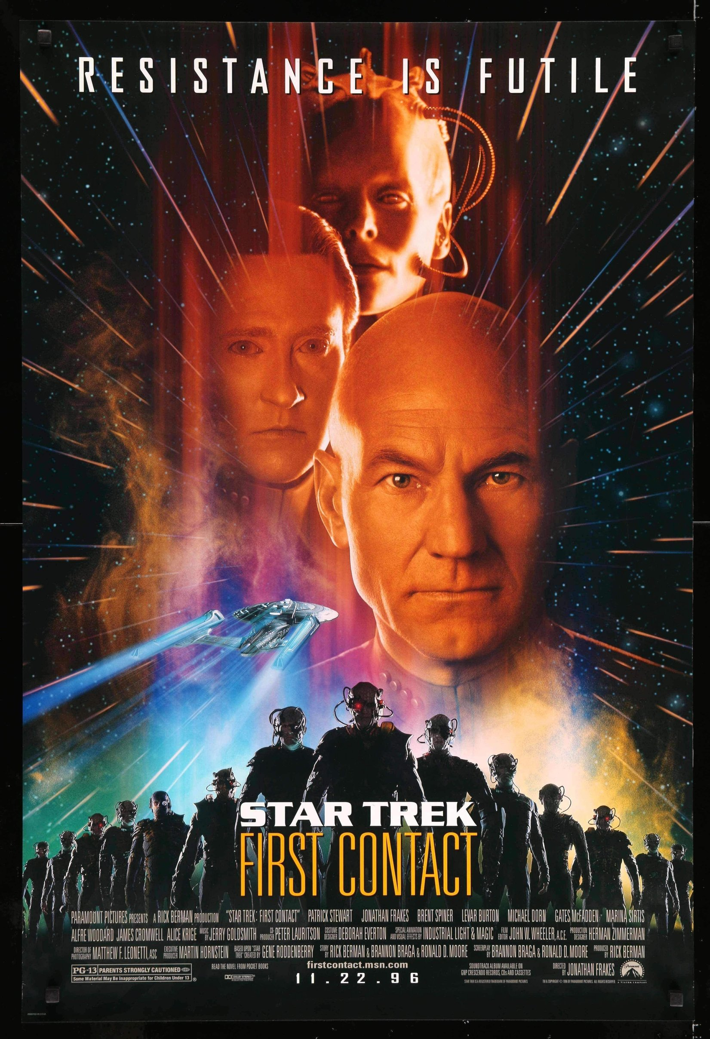

H

2nd Practice Paper – 2019

Higher Media Practice Paper 1:
Analysis of media content

Date — 2018-19
Duration — 2 hours 15 minutes

SECTION 1 — ANALYSIS OF MEDIA CONTENT IN CONTEXT— 40 marks Attempt ALL questions.
SECTION 2 — ANALYSIS OF MEDIA TEXTS — 10 marks Select ONE PAIR from the following media texts: Pair A — Film posters (pages 04–05) or
Pair B — Magazine covers (pages 06–07) or
Pair C — Advertisements (pages 08–09) and attempt the question on page 03.
Write your answers clearly in the answer booklet provided. In the answer booklet you must clearly identify the question number you are attempting.
Use blue or black ink.
Before leaving the examination room you must give your answer booklet to the Invigilator; if you do not, you may lose all the marks for this paper.

SECTION 1 — ANALYSIS OF MEDIA CONTENT IN CONTEXT— 40 marks

MARKS
Attempt ALL questions
You may refer to one or more than one media text in your response to questions 1 and 2.
1. Internal and external institutional factors often influence the ways that key aspects of media content such as categories and/or representations and/or language are constructed.
Analyse how this statement applies to media content you have studied. In your response you should:

a) give detailed information about internal and/or external institutional factors which have influenced the media content; 10

b) analyse how categories and/or representations and/or narrative have also been influenced by these institutional factors. 10

2. The way that language is used in media content can be influenced by society and audience factors.
Analyse how this statement applies to media content you have studied. In your response you should:

a) analyse the ways in which language has been used in the media content 10

b) analyse how the use of language has been influenced by society and/or audience 10

SECTION 2 — ANALYSIS OF MEDIA TEXTS — 10 marks

Select ONE PAIR from the following media texts:
PAIR A — Film posters
or
PAIR B — Magazine covers
or
PAIR C — Advertisements
and attempt the question below.
Write the letter of your chosen pair of texts (A, B or C) in the margin.
3. Analyse in detail how relevant key aspects of media literacy have been used in similar and/or different ways in your chosen pair of media texts. You must make reference to both texts.

In your answer you must make at least five developed points of analysis, and refer to at least two of the following key aspects:
- Language
- Representation
- Categories
- Narrative
- Audience
- Institutions
- Society

10

