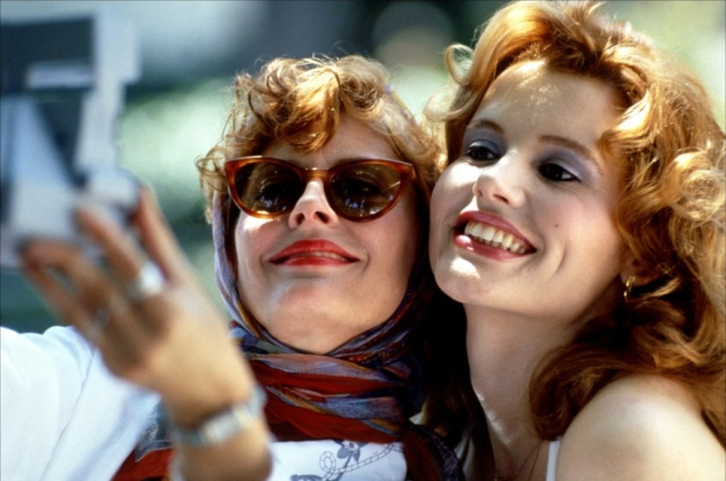

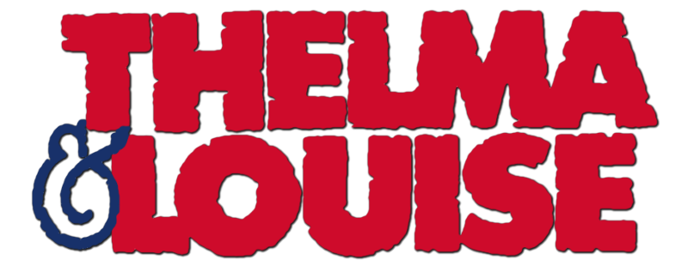

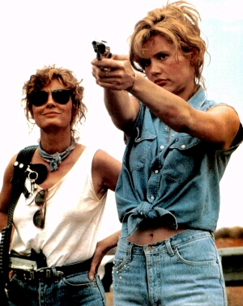

1 – Representation of Thelma & Louise as characters

- We are first introduced to Louise; she is a waitress, a very feminine job. She looks very well presented and ready to serve the general public. However on her break she goes behind the restaurant and lights a cigarette. She picks up the phone and calls Thelma.
- Thelma is dressed in a gown and her hair is all messy, she is shouting loudly making her look quite idiotic. We can see she is a simple housewife by her excitement to answer the phone because she will be doing nothing all day.
- The two speak about their upcoming holiday and it’s revealed that Thelma hasn’t asked her husband if she can go. This shows the audience that Darrel has a hold over Thelma or some sort of possession, like a father.
- When we are introduced to Darrel we can see that Thelma is very obedient towards him. She tries to appeal to him buy fastening his bracelet, offering him coffee and asking what he wants for his dinner. His response to this is very angry and cruel. He shuns Thelma when she tries to speak to him and he acts superior to her. He reveals he may also be cheating on Thelma, as he stays late on Fridays at work.
- Thelma decides to leave her husband at home at go on holiday. This is where the packing montage begins. The two are represented very differently. Louise is very precise and knows exactly what she is bringing, as it is all packaged in sandwich bags and neatly folded.
- Thelma however is just dumping things into her suitcase. She is pulling out drawers and emptying them in and taking clothes out of her wardrobe and throwing in the hangers still on the clothes. This shows she
- Louise is tidying as she goes and Thelma is leaving a whirlwind of mess behind her. This represents her immaturity as she has never been away without her husband so does not know what to pack.
- When the two meet it is clear that Louise is more mature than Thelma. The way she speaks too her is similar to that of a mother to a daughter.
- They set off on their holiday, a while into the journey they stop at a bar, here we are introduced to Harlan, a flirtatious regular at this bar. Louise sees right through his flirting but Thelma thinks he is just being nice. This emphasises her naivety.
- Louise seems very tense in the bar, her hair is up and her body fully covered. Thelma is having fun, her hair is down, she is dancing, and she has a drink in her hand.
- She is dancing with Harlan. The excessive spinning makes her feel ill so he convinces her to go outside with him for fresh air. She is shown to be vulnerable.
- After she has been sick Harlan comes onto Thelma but she rejects him. This angers him and he hits her. She is beginning to realise the severity of the situation. She hits back which is when Harlan attempts to rape her.
- Before he can carry on Louise puts a gun to his next. She appears very distraught but collected at the same time. She is very assertive to Harlan, showing she is the one in control. He is very arrogant to her, and tells her to suck his dick. She shoots him in the chest.
- Thelma is immediately distraught but Louise commands her to get the car, emphasising the mother daughter relationship we saw earlier in the film.
- They leave the scene and begin their run from the police. Thelma wants to go to the police straight away but Louise somehow knows that their story would not be believed because of the society they live in.
- Louise decides she is going to travel to Mexico so gets her boyfriend jimmy to transfer her money. On her way to go the money the two women pick up a hitchhiker named JD. Thelma is clearly attracted to him.
- Thelma and JD have sex and she leaves him in their motel room in the morning. Louise realises how stupid she has been as JD has stolen their money. This is where we see a change in both their characters.
- Louise now appears much more emotional as she breaks down. Thelma is now the one who takes charge and decides they should push on to Mexico.
- On their way Louise is still emotional. They stop at a convenience store which Thelma robs at gun point. This changes the way she is represented from small minded housewife to independent cunning women.
- On the run the women get payback on a rude truck driver. They pull him over by tricking him into thinking he’s getting sex. In this scene the women’s characters have clearly changed. Their body language has change dramatically from the start of the movie both woman seem very confident and open with themselves. They then shoot at his truck as he doesn’t apologise to them and it blows up. They then drive away laughing leaving the man wallowing in self pity.
- They then continue to drive onwards until they begin to get chased by a helicopter, they try to turn around but there is a wall of police cars and police men with ammunition. They get asked to leave the car by the detective but the two women both significantly more brave than the start of the film decide to drive onwards. This is significant because it is Thelma who says too “keep going” into the Grand Canyon whilst holding hands.

2 – Representation of Women

- At the beginning the women are represented to be particularly domestic and ruled by men. They also have particularly stereotypical jobs – such as housewives and waitresses.
- When Thelma says “I’ll have to ask Daryl,” it shows that she is ruled by her male other half, and doesn’t do anything without his consent.
- Jimmy shouts at Thelma as though she is an object. This shows the large quantity of disrespect he shows towards her. This is the first time she sticks up for herself when she says “Go Fuck Yourself,” which reflects n the fact she is standing up for herself and is no longer willing to be treated like an object.
- Thelma jumps to Daryl’s needs – perhaps this is the case for all women of this time era.
- “When are you going to run away with me?” Shows women are desirable sexual objects to men. Women are allowed to hug/kiss without being considered lesbians – although this can perhaps be interpreted differently if this was men.
- Women feel pressured into being like other women, such as the fact that Thelma smokes in order to be like Louise.
- Men interested in getting them drunk – women maybe slightly vulnerable. Their superiority is shown when Thelma is being raped and Louise pulls out the gun – this shows their ruthlessness and independence and the length they are willing to go to support each one another. Thelma is a sucker for flirting and this is shown in the scene when she gets raped due to the fact that she was flirting with the man all night.
- Thelma doesn’t tell Jimmy about the weekend away – shows his superiority as she is scared about telling him as she feels he will disapprove of the idea.
- The women are pursued to be more confident than they were at the beginning – especially Thelma, due to not being ruled by Daryl. Thelma is coming out her shell more and more as the film progresses.
- Truck driver makes abusive gestures – showing he would use Thelma and Louise as sexual objects. On his truck there is a cut out of a naked women showing the main interest the man has in women. Thelma and Louise are both quite intelligent – due to the fact that they can cover their ground for so long – on route to Mexico.
- Louise is a motherly figure to Thelma throughout the film.
- The women are also portrayed to be talking about issues that women are not stereotypically interested in – such as sex and relationships.
- They are stereotypical women due to the fact that they wear nice clothes and have their makeup done, they care about their appearances and are careful with looks
- Their car is feminine and they are wearing sunglasses too. Women use bathrooms to check themselves out. Thelma and Louise can stand up for themselves. Women are at an advantage as they are able to be violent towards men and men aren’t able to retaliate.
- They are strong women, honesty vs unhonesty. Emotional and crying – shows the women are getting stressed by the encounters they are facing.
- The women both have their hair down symbolising the fact that they are free. The women are both in relationships and they are ‘loved.’
- The women are seen as independent – at this time era – women weren’t considered to be independent.
- Check themselves out in the mirrors and do their makeup.
- Strong and independent.
- Sing along in car and dance. Men watch the women in a sexual manner as they dance in the club – as they desire the women. All the men is interested in is having sex with the women where as the women are only interested in dancing and having a good time. This shows that the women like to dance and this therefore shows that the women are interested in dancing.
- Throughout the film it is clear that sexual attitudes are reinforced. Women’s bodies are treated as rewards to men.

3 – Representation of Men

Darryl
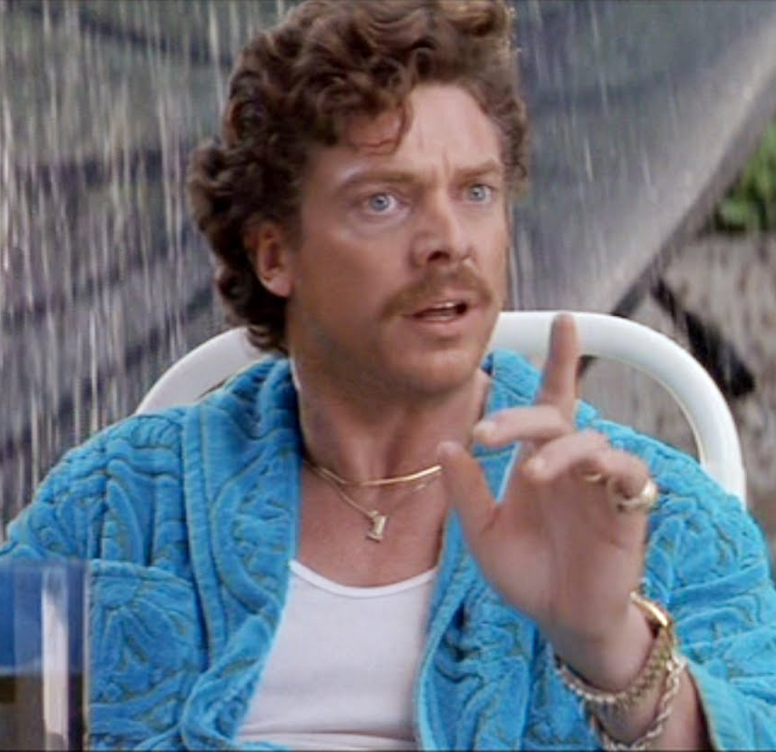
- Ignores everything that doesn’t affect him, loves himself, doesn’t care about anything but himself
- The boss in the house, breadwinner, he has more power than Thelma
- Swears a lot, talks very badly towards Thelma
- Sets the rules
- Impatient
- Aggressive- language, shouts and screams at Thelma, arrogant and very ignorant
- Dumb- stands on his pizza
- Clumsy
- Acts like a rich kid, car, and shows off`
- Watched football, concentrates more on football than his wife, typical man and very messy when Thelma is not in the house, stereotypical husband
- He acts like he is Thelma’s father
- He doesn’t really care about Thelma when she goes away, doesn’t really know her
- He is like a child, needs everything done for him
- Worries more about money than Thelma- phone scene: when they tell him that they are going to charge his phone his first reaction is ‘is it going to cost me?’
- He doesn’t think he is doing anything wrong, he thinks that the relationship between him and Thelma is good
- Very difficult for him to socialise with Thelma
- Doesn’t like romantic movies, stereotypical man
- Very childish
- Spoilt
- Doesn’t care about Thelma, not loyal to her after all the things she does, like housework
Harlan- the rapist
- Hides his bad side
- Liar
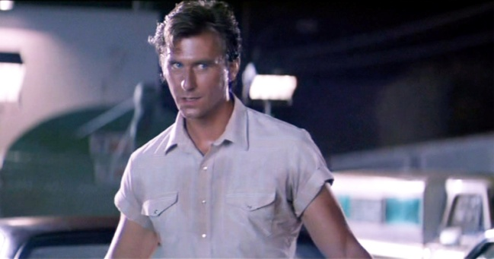
- Spoilt
- Very flirty, wants to get it on stereotypical man
- Very annoying
- Nice to the victim, Thelma, sleazy, hitting on Thelma
- Tries to be cool towards the victim
- Makes bad jokes, tries to leave an impression on her
- Drinks beer, goes to the bar, wants to dance with woman
- Invites Thelma to dance, holds her very tight, slightly choking her, kind of possessing her like Thelma is his, he knows that Thelma is not going to do anything
- Brings Thelma out to the parking lot when she need fresh air
- Harassing Thelma when she wants to go inside, he forces her to stay outside
- Forced her into a car and starts kissing her
- He hits her, very violent
- Aggressive
- Swears a lot, uses Thelma because of her looks
- He doesn’t care; he just gets on with it
- Tries to rape Thelma
- He doesn’t stop until Louise holds a gun at his neck
- Doesn’t have respect for women
- Last words – ‘suck my d*** ’

The trucker
- Can’t speak properly
- Bad language, very bad manners towards women
- Treats women like they are objects
- Not very good looking
- Disrespectful
- Bad slang
- Extreme sexist, the picture of a naked woman on his truck
- Dumb
- Idiot
- He is disgusting, the way he acts, the thing with his tongue

JD
- Very young
- Attractive
- Polite at the start, has good language towards Thelma and Louise, he knows when to apologise, very respectful
- Steals the money from Thelma and Louise
- Tells the police guy where Thelma and Louise are going
- Acts naive, cute guy
- Cowboy

Jimmy
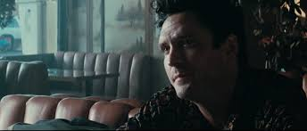
- Very supportive of Louise, he doesn’t want to lose her
- He is not like the other guys in the film
- He helps Louise out, he travelled a long way just to give her money
- Attractive, Muscular and strong, Tall, big build
- Aggressive- the table scene when he’s drunk
- Proposes to Louise when he’s drunk
- Not romantic
- He can’t decide over Louise, doesn’t have anything under control
- Loyal to Louise
- Doesn’t ask her question about what happened
- He trust Louise, but afraid to lose her
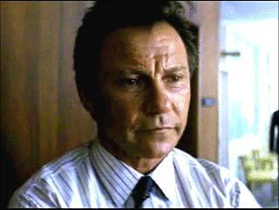
Police
- Very supportive towards Thelma & Louise
- The leader does his best to help them out, want them to confess
- Smart, ‘good guy’, polite- detective Hal Slocumb
- He’s on Thelma & Louise side until the very end- when he runs after the car screaming ‘don’t shoot’
- Screams at J.D. giving him the fault because he stole the money
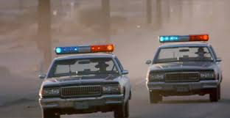
- Romantic, having fun- running under the rain laughing or watching a romantic movie while work, sloppy
- Guy that was forced into the trunk of the car acted in the beginning like a ‘tough guy’ but stars to cry like a baby when Thelma points a gun at his head
- Incompetent in some scenes

4 – Representation of America / Americans

Positive

At the start there is the wide open road, which represents the American Dream with freedom and escape from whatever they are running from, in Thelma and Louise’s case is the police. The bright open skies beyond the road can also relate to the American Dream, as they represent happiness and the endless possibilities it promises.
The music then changes to a happy upbeat tune where the scene changes to an American diner. This is a representation of the warmth and community shown by Americans and the patriotic enthusiasm they share for their country.
Louise’s 1966 Ford Thunderbird shows a road trip will take place and is a representation of Hollywood’s glamour as it is an expensive convertible.

Thelma’s husband, Darryl, is shown as a successful business man as he had a nice house, fancy car and a gardener and worker. This is representative of the American Dream and the American Hierarchy, where Darryl is near the top.
However the police investigator Hal is kind and respectable towards the women throughout the film wanting to give them the benefit of the doubt by not showing force suggesting that the police are reasonable.
The Polaroid of Thelma and Louise backs up their friendship as they are close. This shows how they trust each other, since they are going on a trip. This also represents their friendship and how it carries on even after their death, as the picture flies out the car when they plummet to their deaths.
The film is shown as a buddy film as Thelma and Louise stick together throughout the film. This is because their friendship is strong and they are never apart.

Negative

The large, open, dry landscape of the desert roads may show that the land is barren which demonstrates that there are times of trouble ahead.
The indoor scene with the diner and bar which are crowded and cluttered and is tainted with smoke. This is because there are a lot of people and the rooms are seen as gray because of the smoke giving mysterious connotations.
Americans are also shown as unfaithful to each other with JD and Thelma who shows that passion overrules the sanctity of marriage.
Thelma is shown to have alcohol in her system for the entirety of the movie after her rape, this is a representation that Americans love alcohol and that it changes her personality. She also keeps eating a bar of chocolate and putting it away and taking it out again. This is a representation that Americans have a lack of self control about themselves succumbing to guilty desires.
We see a gun in the first scene of the film which suggests it will be used later on in the film. The gun is a phallic symbol which is representative of the male influence and stereotype held by them. Using guns as a sense of self defence is used due to law suggesting that Americans are rash in decision making however it is perhaps the most rational decision in the case of Thelma and Louise who are wanted for murder therefore being a threat to the general public. We also see a number of police who have guns and use them against Thelma and Louise, such as in the montage of them loading guns in the climax showdown beside the Grand Canyon.
Harlan the man who rapes Thelma outside the bar is aggressive and forceful suggesting that he is shallow and heartless and is subjective to the stereotype of macho selfish American males. He is married and appears to treat women as objects when the waitress at the diner states she is surprised that no one had killled him in vengeance already by making Thelma feel vulnerable enough to step outside with no one watching when she feels ill and try to take control of her body and mind while intoxicated.
Thelma is in possession of a gun as most Americans have one in their home for self defence however the fact that Thelma is a normal stereotypical housewife. You do not initially believe that she is emotionally and mentally stable to use it throughout the film but she is pushed to use it as she grows in confidence and the walls are closing in on her almost.

Challenging stereotypes

Stereotypically stupid and not capable of making big decisions such as Thelma who is seen as wide eyed and incapable of being dominant however as the movie progresses she takes over from Louise in the dominant role and both women fight for their lives effectively for almost the entirety which is very much unseen by American cinematography.
Road trip movies are characteristically shown to occur in America with duos that are running from the truth.
Americans are stereotypically represented as having a substantial figure due to overeating and gluttony however in this film many of the main characters in the movie are seen to be slender or average weight.

