Design and Manufacture – Higher
Materials

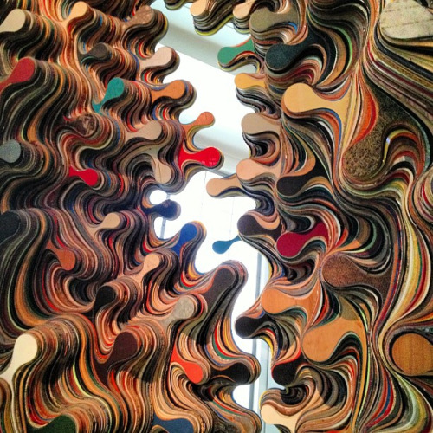
Contents

Wood, Natural Timbers 3
Hardwoods and softwoods 4
Manufactured boards 5
Metals 6
Ferrous metals 7
Non-ferrous metals 8
Plastics 9
Thermoplastics, thermosetting plastics 10
Composite materials 11

Wood
When investigating wood it is important to know that there are two main categories:

- Natural timbers and
- Manufactured boards

Natural timbers
These can be split into two further categories: hardwoods and softwoods.

Natural timbers need to go through a number of processes in order to convert the logs into useful boards.

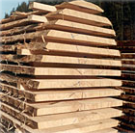
1. The log is rough sawn into parallel slices or planks.
2. The planks are then stacked with gaps between each layer for seasoning. Seasoning removes unwanted sap and moisture from the wood and can either be done by air drying or in a kiln. Air drying can take several years whereas kiln drying can take a matter of weeks.
3. The rough sawn and now dry timber is cut and planed into useful sizes.

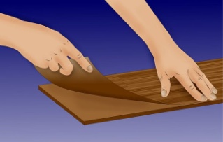
The conversion of logs into useful timber sections is expensive and manufacturers try to find alternative where possible. Veneers (thin slices of wood) are often used to disguise cheaper timbers such as manufactured boards.

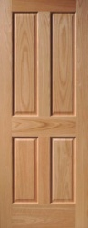
Natural timbers are prone to warping and twisting. Furniture designers limit this by avoiding wide sections of wood, gluing several narrow sections together to form a wide board or by the use of expansion gaps for example in panel door construction.

Hardwoods
Hardwoods come from deciduous trees that lose their leaves in winter. Hardwoods are slow growing and therefore expensive. They are however generally more dense and durable than softwoods. Hardwoods can vary from pale (such as Maple and Sycamore) to dark (such as Walnut) and are often chosen when designing furniture to give a specific look.

Oak
Oak is a strong and durable timber that is ideal for furniture and applications where a hardwearing material is required. Used for all types of furniture, expensive house frames and flooring.
Beech
Strong and durable like oak but also resistant to splintering making it ideas for flooring, work benches, mallets and children’s toys such as Brio train sets.
Ash
A tough and flexible hardwood that is used for sports equipment, tools handles and applications where the wood is steam bent such as chair backs.
Mahogany
A tropical hardwood with a fine grain that is available in wide boards. Used for high class furniture, boat interiors etc. Alternatives are often preferred because in many cases tropical rain forests are often ruined in order to log the timber.
Walnut
A dark timber with an attractive cross grain (i.e. the grain pattern runs in different directions). Cross grain make the wood difficult to plane. It is used for furniture, gun stocks and veneers.
Teak
Teak is a tropical hardwood that is hard strong and durable. Natural oils in the wood make is resistant to moisture and is has been widely used for boats, kitchen worktops and other applications where is would be in contact with water. Due to concerns with deforestation of tropical rainforests, Teak is not used as widely now as in the past.

Softwoods
Softwoods generally come from coniferous trees most of which retain their needles in winter (one exception being Larch). Softwood trees grow quickly (30-40 years in some cases) and are therefore cheaper than hardwoods. Many softwood trees are very resinous and this makes them ideas for outdoor applications such as cladding on buildings.

Scots Pine
A relatively string knotty wood that is widely used for joinery and construction work. It is cheap and readily available. Use for house frames and internal joinery and low cost solid wood furniture.
Red Cedar
A straight grained softwood that is durable outdoors because of natural oils present in the wood. Use for internal and external timber cladding.
Spruce
Parana Pine
A hard, straight grained knot free softwood with a relatively straight grain. Used for high quality interior joinery.

Manufactured Boards
Manufactured boards are created by combining wood chips, fibres sheets or strips with resin to form large standard sized boards. They have many advantages over natural timbers such as:
Low cost – manufactured boards are cheaper alternatives to natural timber.
Available in wide boards – they are generally supplied in 1.2X2.4m sized boards in a range of thicknesses.
Stable- manufactured boards are less prone to warping and twisting.
Cheap boards can be ‘disguised’ with solid wood veneers.

Common manufactured boards:

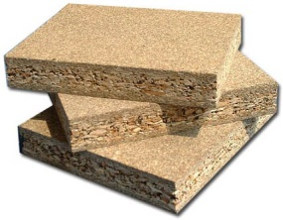
Chipboard
A cheap material made from wood chips compressed with resin into boards. Chipboard is an ideal material for wood carcasing such as kitchen cupboards, bookshelves etc. It is often veneered with solid wood or plastic laminate. Edges are prone to chips and therefore solid wood edging is sometimes used to increase the durability of the product.

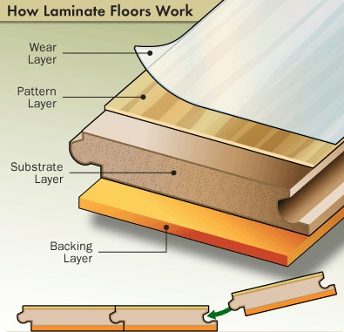
MDF
Medium Density Fibreboard (MDF) is made from wood fibres compressed with resin into boards. It has a smooth surface making it suitable for painting or veneering. Fine details can be machined into MDF and it is used as the substrate for laminate flooring as shown.

Plywood
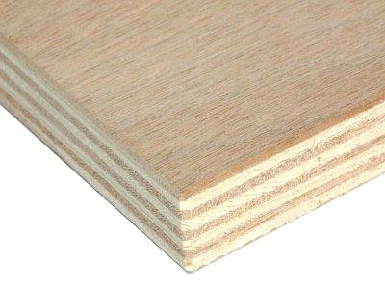
Plywood is made by gluing veneers (thin sheets of wood) together. The grain on each layer runs at 90degrees to the previous layer making it strong. Plywood or laminated wood can also be glued into a 3D shape. This has many advantages such as minimising joints and adding strength and stiffness to a product. Plywood is used for making chairs, boats, skateboards etc.

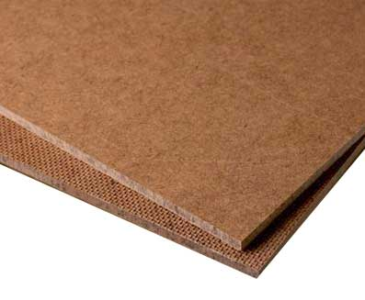
Hardboard
Hardboard is made in a similar way to MDF but is less dense and comes in thin sheet sizes (2-4mm). Hardboard is generally uses as a backing board for furniture such as cupboards and drawers.

Metals
What images does the word ‘metal’ bring to mind? Factories, cold-to-touch surfaces, scrap yards, tin cans, rock bands with long hair and screaming guitars? Or does it register the basic building blocks of 20th century existence – iron, steel and aluminium?

The story of metal in design history is a curious one, since its role has gone from decorative to functional to decorative again as fashions have changed and materials have developed. Early civilisations are known for metals they worked, in that we talk of the Iron Age and the Bronze Age. In those societies metals were precious and their use was restricted largely to valuable, ceremonial and other highly wrought objects. At the time of the industrial revolution, iron and steel were looked on as grimly functional materials. They were gradually assimilated into everyday life and eventually used for decorative purposes by the most adventurous architects, engineers and designers. Today, many of the most innovative furniture and product designers use iron, steel and aluminium for what we now see as their positive aesthetic virtues.

The variety of articles manufactured from metal is enormous. The range of different metals is equally vast.

As with wood and plastics, metals can be grouped into two main categories:

- Ferrous metals – contain iron and are magnetic
- Non-ferrous metals – do not contain iron and are not magnetic

In addition metals can be further split into base metals and alloys:

- Base metals – pure metals
- Alloys – mixtures of metals and other elements

Different metals are chosen for different tasks to make the most of the properties they possess. These properties can include elasticity, toughness, brittleness, malleability, hardness and ductility.

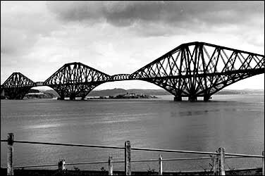
Ferrous Metals (contain iron - magnetic)

Cast Iron
A brittle with a hard skin that is ideal for casting. Used to make vices, drain covers and “heavy” sections of machine tools.
Mild Steel
A malleable and ductile metal that is good for things that require to be pressed or cut into a shape. Its low cost and easy workability makes it a common choice of metal for a wide variety of items such as filing cabinets, staplers, casings for domestic goods such as washing machines etc. Mild steel will rust if left outdoors so is usually given a protective finish such as paint, plastic coating, galvanising or electroplating. Used to make electric socket boxes, nuts, bolts, car body parts, etc. It is also heavy compared to metal such as aluminium so is used when weight performance is not an issue.
High Carbon Steel
A malleable and ductile metal that can be hardened and tempered. Use to make all types of cutting tools (drills, lathe tools, taps & dies, etc.) plus hammers, etc.
High Speed Steel (alloy)
A very hard but brittle metal which does not soften at high temperatures. Used for all types of cutting tools.

ALL OF THE ABOVE METALS WILL SHOW SIGNS OF RUSTING

Stainless Steel (alloy)
A hard and tough steel alloy that is corrosion and wear resistant. Used for kitchenware, boat fittings, etc. Stainless steel is heavy like the others steels above but will stay shiny silver in colour.

Non - Ferrous (no iron - not magnetic)

Aluminium
Aluminium has a high strength to weight ratio and is often used where weight and strength are important considerations. It is easy to cut and shape and its low melting point makes it suitable for a variety of casting processes. Used for making window frames, food packaging, pots & pans etc.
Copper
A tough, ductile and malleable metal that is also a good conductor of heat and electricity. Copper does not rust if left outdoors. Instead, a protective oxide layer forms on the surface that eventually turns green. It is sometimes used for a roofing material. Used for plumbing pipes & fittings, electric wires, pots and pans.
Zinc
Zinc is weak and difficult to work but does not rust and has a low melting point. It is often used as an alloy for casting or as a surface coating on steel (galvanising). Cast zinc components are normally of low finish quality and look dull grey.
Brass (alloy of copper and zinc)
Brass is an alloy of copper and Zinc with a yellow/gold colour. It is corrosion resistant, hard, a good conductor, easily joined, casts well and polishes well. Used to make taps (as in water), decorative items, door’ furniture’ such as handles and letterboxes, boat fittings and castings.
Tin
Tin is a soft metal with a low melting point. It has excellent resistance to corrosion so is used to ‘plate’ metals such as steel in order to prevent corrosion.
Lead
Lead is very heavy and soft. It is also malleable and has a low melting point. Lead is corrosion resistant and is widely used in roofing as flashing joints between slates and a wall or chimney. Lead is poisonous. It used to be used for plumbing in old housed but in most cases it will have now been replaced with copper piping.

Plastics
Plastics are widely used in product design today because of their versatility and ease of processing.

There are two main groups;

- Thermoplastics. These can be heated and re-shaped many times e.g. acrylic, polystyrene, ABS

- Thermosetting plastics. These can only be heated and shaped once e.g. melamine and urea formaldehyde.

Plastics have a number of advantages over other materials such as wood and metal. For example they are lightweight so are increasingly being used for non structural components in cars such as bumpers or side panels. In houses they are used for window frames, window sills and exterior facings. The fact that they can be coloured during processing and do not require further painting or protection makes them ideal for such applications.

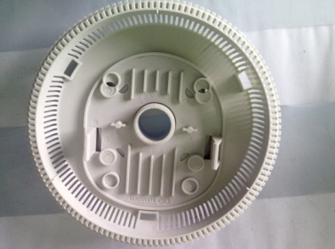
Plastics can be easily moulded into complex shapes which have integral fixings thus making assembly quick, low skilled and cheap.

They do not rust or rot outdoors so are ideal for outdoor applications such as garden furniture.

There are of course some disadvantages of plastics, including;

- Environmental issues over disposal/recycling
- Made from non-renewable raw materials
- Associated with cheaper, low quality products
- Loss of skilled labour

Thermoplastics

Polypropylene
Polypropylene is a relatively rigid plastic with a quality finish. It has some flexibility to it so is used for products that require a little give such as chairs. Polypropylene will not break or crack when bent back and forward so is often used for ‘flip top’ caps on shampoo bottles.
High Density Polyethylene (HDPE)
This plastic is flexible and tough and used to make a wide variety of packaging such as milk jugs and plastic bottles. It has a cloudy look to it or it can be coloured. HDPE can be sterilised and is suited to applications where wear and tear is an issue. HDPE will scratch and scuff easily. Used to make school chairs, stacking boxes, wheelie bins etc.
Polystyrene
Polystyrene is a rigid plastic that has a good finish. It has a relatively low impact resistance so can crack if dropped. Polystyrene is used for a variety of items such as model kits, toys and TV casings.
ABS
ABS comes from the same ‘family’ of plastics as Polystyrene but has a high impact resistance and a high quality finish. It is resistance to scuffs and scratches and is used for phone casings and other electronic equipment where durability and a quality look are important.
Acrylic
A hard and brittle plastic with a high quality finish. Acrylic is available in many colours and has good light transmission properties. Often used for shop signs and displays.
Polyvinyl chloride (PVC)
A tough and relatively stiff plastic that has good chemical and weather resistance. If used outdoors it needs to be stabilised (uPVC). Widely used for plastic window frames, conservatories, guttering etc. The flexible version (plasticised PVC) is used for clothing and bags.
Nylon
Nylon (or Polyamide) is generally creamy white in colour and is hard and resistant to wear. It has good temperature and chemical resistance and is widely used for moving parts such as gears and bearing surfaces e.g. in electrical equipment motorised toys etc.

Thermosetting plastics

Melamine
Melamine is a rigid thermosetting plastic that can be coloured. It is used for a variety of kitchen utensils such as spatulas, children’s cups and plates. Like all thermosetting plastics it is resistant to heat but brittle.
Urea Formaldehyde
This thermosetting plastic is white and commonly used for electrical fittings such as plug sockets, light fittings etc.

Composite Materials

A composite material consists of two or materials added together to make a new material with enhanced properties. Composite materials are generally used where performance is an important issue for example to provide increased strength or a light weight product.

Common composites

Glass reinforced plastic (GRP)
GRP is made by combining layers of woven class fibres with polyester resin (see Manufacturing processes booklet for more information). The resulting structure is generally light and strong. GRP is frequently used to make boats, kit car bodies, baths and other large hollow structures.

Carbon fibre
Carbon fibre is made in a similar way to GRP but by using carbon fibre (see Manufacturing processes booklet for more information). Carbon fibre components are very light and strong and it is used for high performance products such as Skis, tennis racquets, racing bike frames, aerospace parts etc.

Reinforced concrete
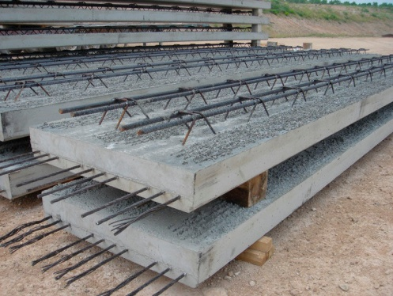
This is often overlooked as a composite but is a good example of combining two different materials. The steel bars provide high strength and the concrete provides the rigidity. Reinforced concrete is widely used in the building industry and has revolutionised the shapes of building structures.

