Task - Tests for Readiness

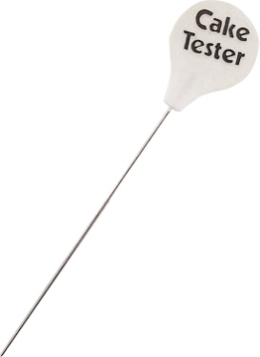
When baking cakes, they need to be tested for readiness. Readiness is the time they are cooked and ready to be removed from the oven. What are the tests for readiness for a sponge cake?
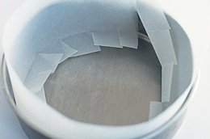
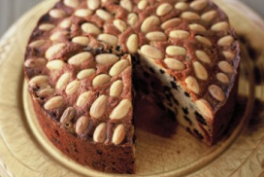

Task - Lining a Sandwich Tin Task - Draw and label how to line a deep, round cake tin
Describe how to line a Sandwich tin

Step 1

Step 2

Step 3

Step 4

Step 5

Functions of Ingredients
Task – Functions of Sugar.
Research the different types of sugar that are used in cake making. An example has been completed for you.

TYPE | DESCRIPTION | RECIPE | FUNCTION IN THE CAKE
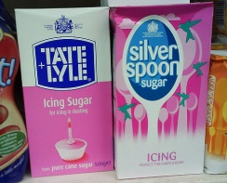  ICING SUGAR | Made by crushing granulated sugar to a very fine powder in a special mill. Anti caking agent is added to prevent the sugar going lumpy | Custard creams  Empire biscuits  Iced lime tray bake | Adds sweetness to baked goods especially as toppings for cakes and biscuits.  Can be used to sweeten foods such as cream as well as biscuits such as custard creams
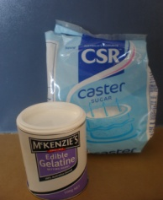
CASTER SUGAR
GRANULATED SUGAR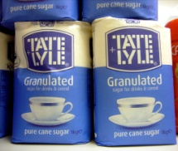

DEMERARA SUGAR
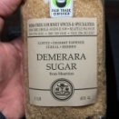

SOFT BROWN SUGAR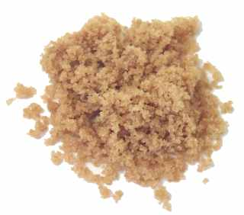

MUSCAVADO SUGAR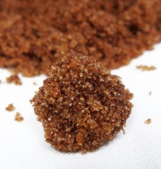

GOLDEN SYRUP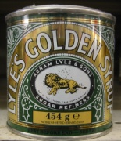

BLACK TREACLE
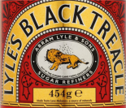

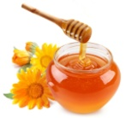
HONEY

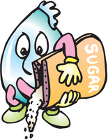
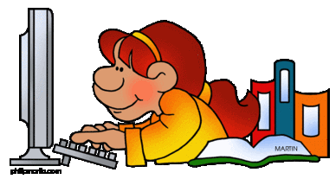
Sugar in the diet – Research Task

Most people are aware that too much sugar in the diet is bad for health. Research has shown that eating a diet high in fructose (fruit sugar) may be even more harmful to health.

Undertake some research in to the pros and cons of fructose.

Produce a poster that explains what fructose is and why it could be so bad for your health.

The following weblinks may be useful
- https://paleoleap.com/10-reasons-why-fructose-is-bad/
- https://www.nutrition.org.uk/healthyliving/healthydiet.html
- https://articles.mercola.com/sites/articles/archive/2010/01/02/highfructose-corn-syrup-alters-human-metabolism.aspx
- https://www.healthline.com/nutrition/10-disturbing-reasons-why-sugar-is-bad

