Snow Day Activities using imagination and natural resources – please also cross-reference other sites on the web for a variety of ideas.
- SNOW PHOTOS – You can take photos of snow on plant life or any interesting light conditions surrounding your home and in your garden. If you don’t have a camera you could instead use your phone camera. Take some scenery photos and if possible some close-up shots. Depending on the weather – it could be sunny or in a blizzard, try and capture the mood and feel of the weather.
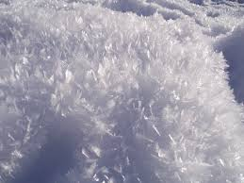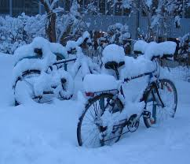

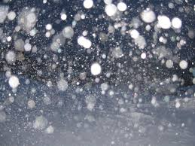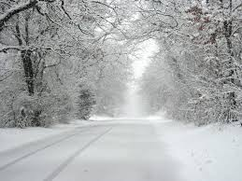

- SNOW SCULPTURE – Taking the average snowman to another level, try and create your own snow sculpture of a person or an animal using your imagination in a situation that looks natural and would make people stop and think. DON’T FORGET TO TAKE A PHOTOGRAPH OF YOUR SCULPTURE!
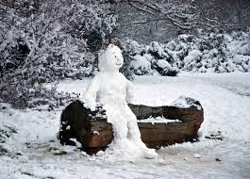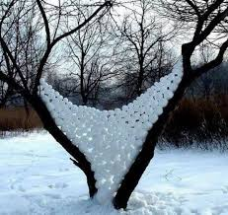
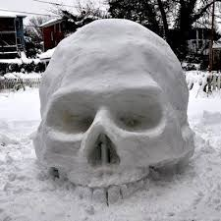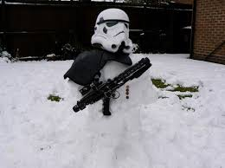
- SNOW DRAWINGS – This should be done in pencil or white chalk on neutral coloured paper, if you have it. Drawing snow scenes requires patience and observation of light and dark to create shape and atmosphere.
- A simple form could be to look at icicles or snowflakes and replicate their shape and pattern.
- Trees or plants looking from your window can be quite challenging as the shape has changed.
- Houses or buildings in general covered in snow make a good composition of shape and light.

