#Composing Music: Chords
A chord is simply a group of notes played together. At a basic level a chord contains 3 notes (called a triad).
Chords work together in families (called keys)

To understand how to form a chord look at the keyboard below:
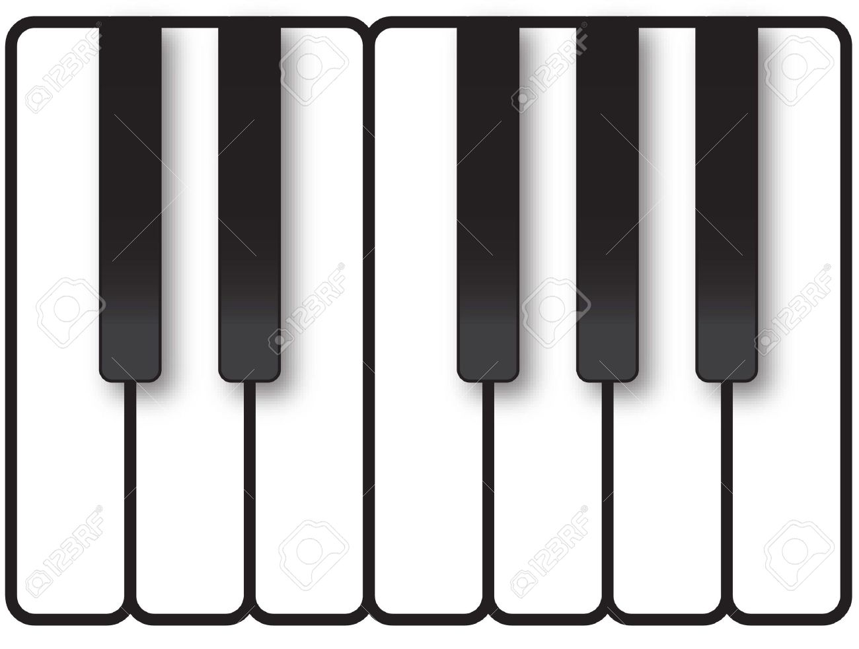
If we play a note on the keyboard, miss a note, play a note, miss a note, play a note – we have a chord.

Families of chords
Chords work in families, meaning that chords are related to each other through keys. Let us look at the key of C Major. This key uses all the white notes on a keyboard starting on C.

1
2
3
4
5
6
7
C
D
E
F
G
A
B
C
D
E
F
G
A
B

Here are the notes Here are the notes and numbers of the scale.
We give the notes numbers because even though the key might change, the numbers will stay the same. For example:
Key of C = C D E F G A B Key of G = G A B C D E F#
1 2 3 4 5 6 7 1 2 3 4 5 6 7
Number 1 is always given to the first note in the new key(called the root).
When we speak about chords we give them numbers. Going back to our C Major key. Chord 1 would be C, Chord 4 would be F, Chord 5 would be G.
What now? On a keyboard, guitar or ukulele, try using the families of chords to put together your own chord progression. At first, start on chord 1 and try moving to different chords. (remember play a note, miss a note, play a note, miss a note, play a note). Choose a maximum of 4 chords.

