Research the different cooking methods below using your iPad.
Write down an explanation of each method and give an example of a food cooked in this way.

- Moist-heat cooking methods
– Boiling:
E.G. - Cooking foods in a liquid at a temperature of about 100° C. Eggs can be cooked using this method. Oil is not necessary however some nutrients are destroyed at this temperature such as Vit C.

– Poaching:

– Steaming:

– Stewing:

– Microwave cooking:

- Dry-heat cooking methods
– Roasting:

– Sautéing:

– Grilling:

– Baking:

- Fry-cooking methods
– Deep-frying:

– Pan-frying:

– Stir-frying:
Using the knowledge you have gained design a 3 course meal where each course demonstrates a different cooking method.

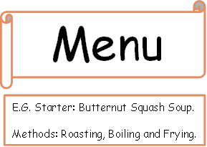

Starter:

Method Used:

Main:

Method Used:

Dessert:

Method Used:

