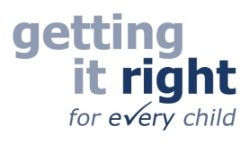
Midlothian Educational Psychology Service
Helpline

Midlothian Educational Psychology Service are now offering a weekly telephone help line, for parents/carers and professionals to discuss any concerns about a child or young person’s learning, social, emotional and behavioural needs.

For advice or to discuss a child or young person with us please phone

0131 271 5615
Thursday mornings from 10.00 – 12.00

Discussions are anonymous and confidential. No records of the discussion will be kept. We may provide you with information, advice or resources, we may signpost you to other services and we may recommend more in-depth involvement with an Educational Psychologist for which signed consent would be required.

Anyone can ring us if they would like to talk to an Educational Psychologist for advice. You don’t need to go to your GP or school to access this service.

