Art and Design News!!!
Look out for these exciting new tasks
FOR AFTER THE HOLIDAYS
on the
S1&2
Google Classroom pages!
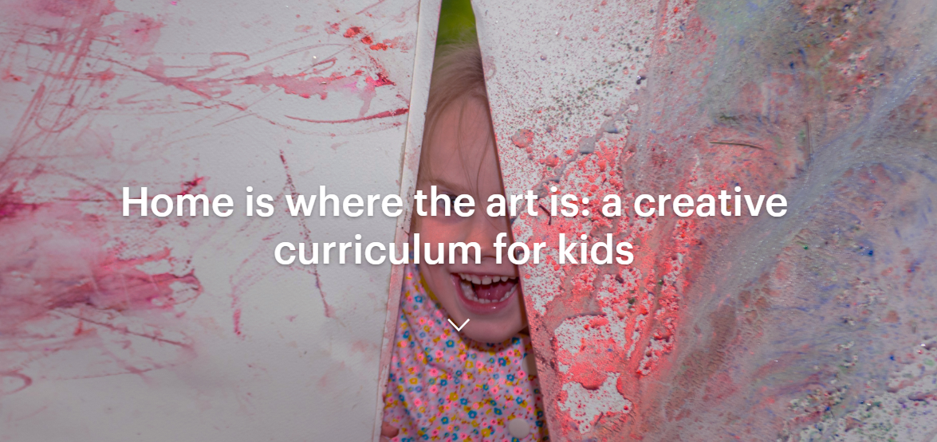

Every Monday, on the National Galleries of Scotland website, they will post 5 creative activities that have been designed for children of all ages to explore at their own pace.
And, of course, grown-ups can join in too – especially with the mid-week #ArtTogether activities!
These wee taster activities have been specially created by the NGS Learning team to enable children and families to make their own discoveries about art. They aim to develop creativity skills, such as problem solving, imagination, curiosity and open-mindedness. Please keep in mind that there are no wrong answers - this is all about looking, chatting, making and enjoying your time at home!
We’d love to see the great art you come up with at home, so please share your photos on our Facebook page or by using #HomeArt on Twitter or Instagram!
We hope you enjoy our ‘pick ‘n’ mix’ Creative Curriculum!

